ELECTRON JS :

JS / NODE

DEMAND IS INCREASING

OPEN-SOURCE SOFTWARE FRAMEWORK

FRAMEWORK : TWO TYPES

SOFTWARE AND WEB

WEB FRAMEWORK : ANGULAR , VUE

SOFTWARE FRAMEWORK : ELECTRON JS : WE CAN USE TO MAKE FOR WINDOWS , LINUX , MAC

JS/ HTML/ CSS

INSTALL NODE AND NPM

MAKE INDEX.HTML , MAIN.JS

USE NPM INIT

INSTALL ELECTRON AND RUN PROGRAM

npm install electron –save-dev

now html file : write some code

also : 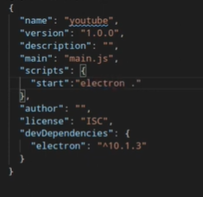

now main.js

const {app,BrowserWindow} = require(‘electron)

function createWindow()

{

take a const win and now create a new instance of browserwindow with given attribues

}

Also to tell when win ready create a window

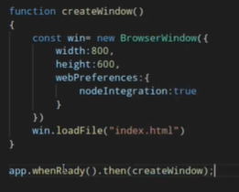

Html / js / css

Electron JS : main.js and index.html

Main.js -> import electron properties

Dev tool :

By default teb

Win.webContents